Analysis of Sexual harassment in Australia

1. **Graph Objectives**

The main objective of this report is to study the relationship between the number of male and female victims of sexual harassment. The mainly found is female victims of sexual harassment are far more than male, in 2015-2016 and their whole life.

1. **Information in survey data**

a) Sexual harassment was considered to have occurred when a person experienced or had been subjected to one or more selected behaviors which they found improper or unwanted, which made them feel uncomfortable, and/or were offensive due to their sexual nature.

b) Sample size: 30,933 eligible dwellings

c) Sample Design: Women: for each State and Territory (and at the national level); Men: at the national level

d) Scope: Persons aged 18 years and over in private dwellings across Australia (excluding very remote areas)

1. **Data choice and data validation**

This report chose the data in table 32.1 and table 33.1. In table 32.1, I mainly use the data about the respondents whether experienced sexual harassment in a different period. In table 33.1, I use the data on household weekly income. Because the Relative standard error of these two parts of the data is less than 25% which can be considered sufficiently reliable for most purposes. Also, some parts consisting of missing data couldn’t use for analysis.

1. **Data management**

The original data is a cross-tabulation which couldn’t analysis by Tableau. I extracted the data which I will use and transferred them to the new excel document. Also, I added three zero for the estimation in table 32.1 to show the big difference between different gender. And I only keep the data which will use later to omit extra filters operate in Tableau. 

Figure 1.



Figure 2.

1. **Visual implantations and retinal variables**

I use pink for women and blue for gender. Because pink and blue are opposite colors, human perception can quickly distinguish. In figure 3, I marked a label on it because there are two gender elements in it. I think it will help the reader to effectively read it. Figure 3 shows the sexual assault in the whole life period and the past year, so the comparison shows that no matter what period, there are more female victims than male victims. And among offenders, male offenders also make up the majority.

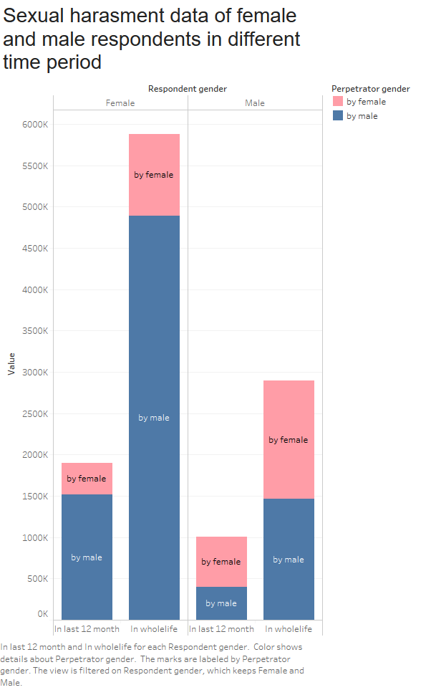

Figure 3.

In figure 4, I use the divergent bar to compare the household weekly income of male and female victims. For the convenience of readers, I continue to use pink for women and blue for men. To show the comparison of the data, I set the fixed axis.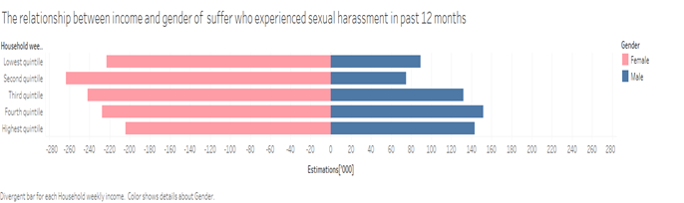

Figure 4.

1. **Key Findings**

In sexual assaults, there are always far more female victims than male victims and regardless of victims’ gender, the offenders are mostly male. Male and female victims also have different weekly incomes. Low-income women and high-income men are more vulnerable to sexual harassment.